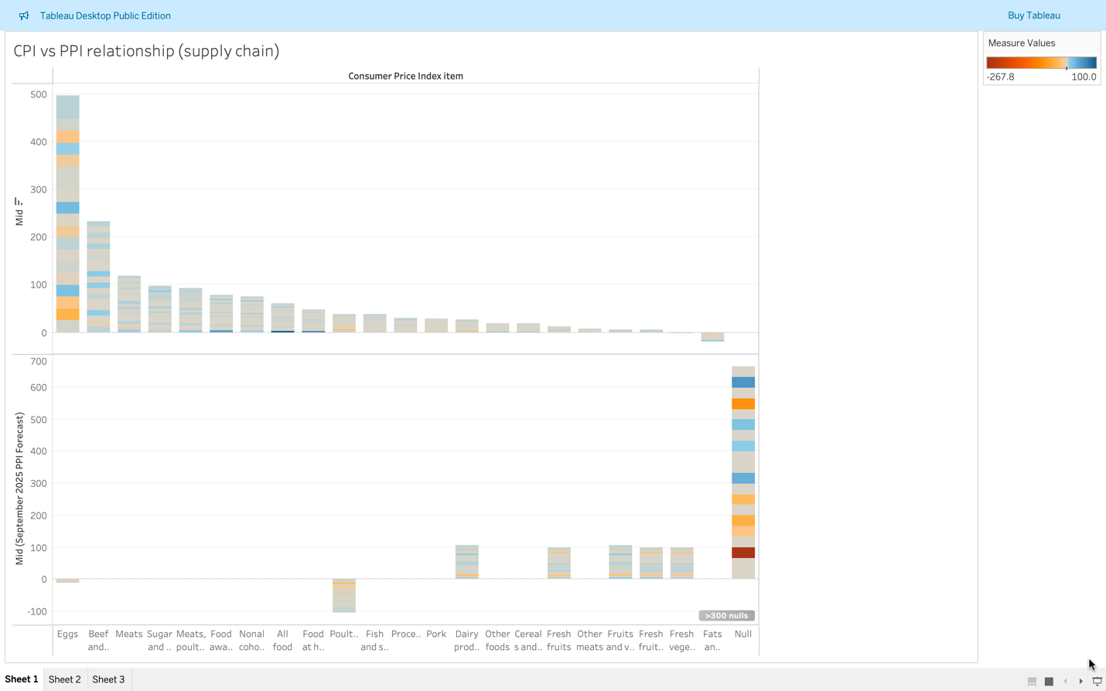
Goal: Compare expected Producer Price Index (PPI) to expected Consumer Price Index (CPI) across food categories. Top is CPI and bottom is PPI

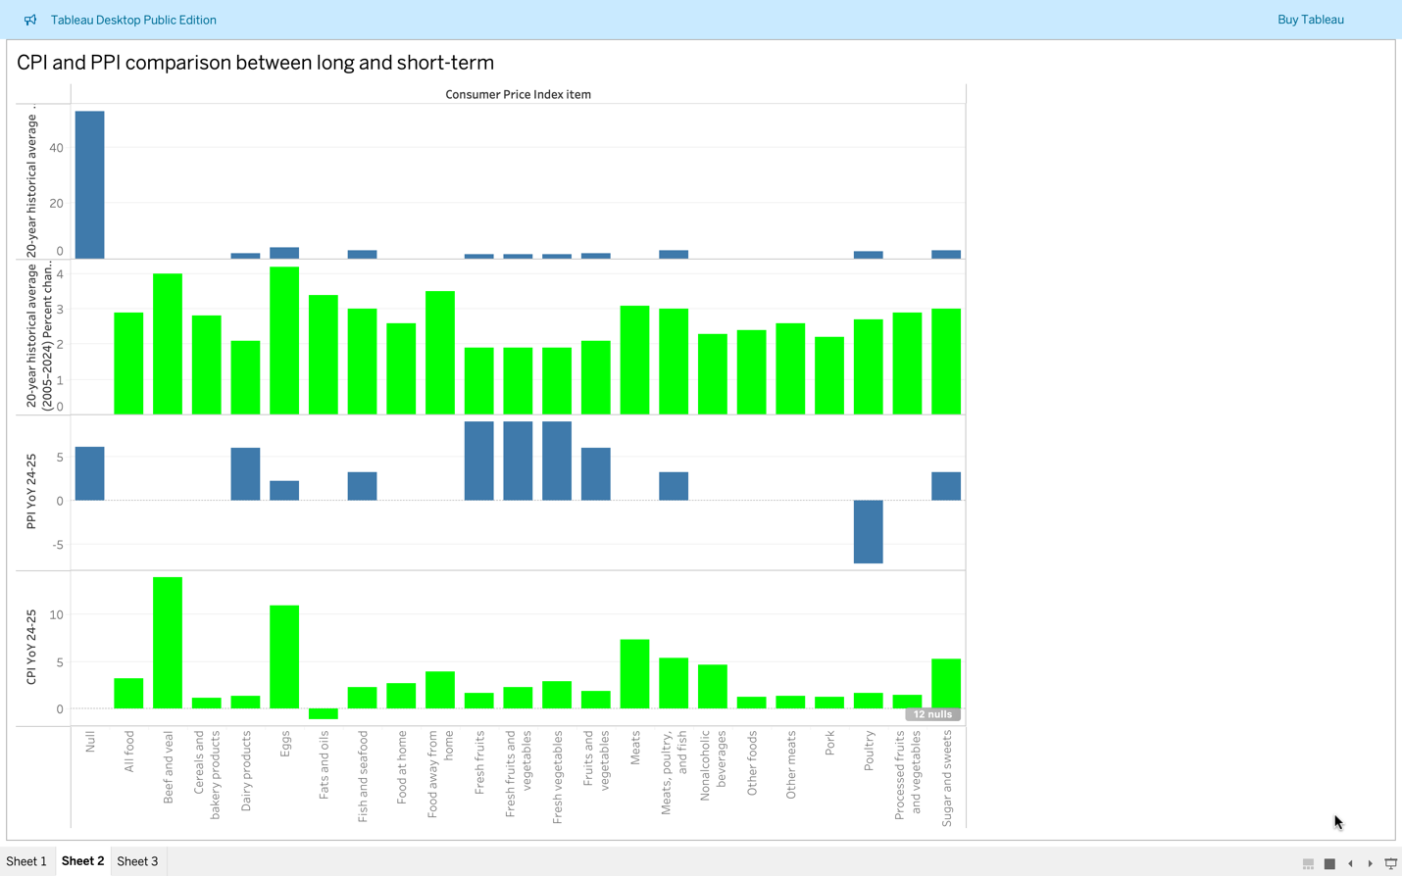
Goal: Show how PPI and CPI compare over long-term vs short-term trends. (Blue is the forecast and Green is the result.

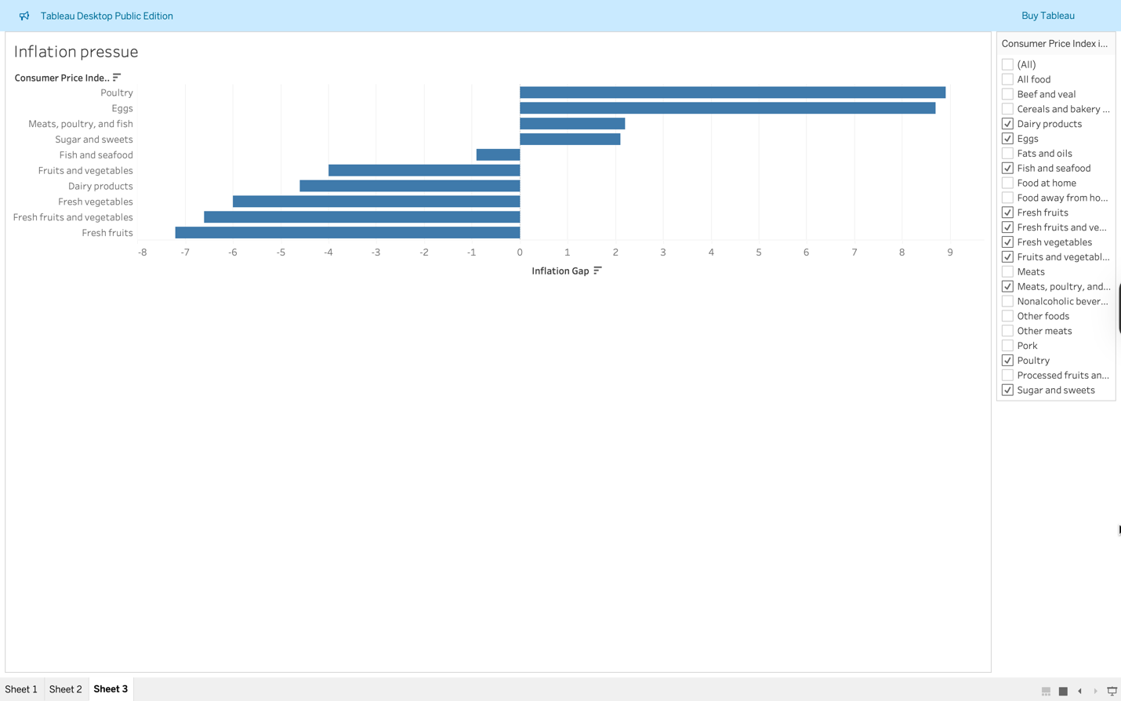
Goal: Show which categories have the highest gap between PPI and CPI, where producer prices are passed on to consumers.

